**California State University, East Bay**

**Business Analytic MS**



**Optimization Model on Buffalo Brewery Transportation cost**

**Submitted by:**

**Ayushi Shrivastava**

**Shubhangi Jain**

**Quyen Wu**

1. **Summary**

The goal of the optimization model presented in this paper is to minimize the transportation cost of a well-known brewery in Hayward, Buffalo Bill’s Brewery. It is a growing and famous boutique brewery among bars around the area so multiple bars place weekly orders with the company. The shipping cost to each bar is different depending on the locations of the bars and the location of the brewery warehouses. Therefore, the higher the total shipping cost, the less profit for the company.

One of the team members knows an employee who works at the distribution department of the company and was able to get an idea of the estimated demand, number of clients and shipping costs. The provided data served as a stepping stone, giving us a base idea to create an approximated inputs and an optimization model for the brewery to figure out how many beer crates to ship to which bar from which warehouse so that minimize transportation cost can be minimized as well as maximize the profit.

In order to achieve an optimal solution and find out the best numbers of crates to be shipped from both warehouses to each bar, Microsoft Excel was used to build the model and Solver add-in to solve the problem. This generated the sensitivity report which helped us to analyze and understand the constraints better. We also used SolverTable to run one-way and two-way analysis reports to see the effects of the constraints on the optimal solution.

This model is built on the basic and simplified data we were given. However, the company can also utilize this model in the future even when it grows bigger and its client base expands. The same logic and mathematical formulas can be applied for optimization and minimization of the transportation cost.

1. **Introduction**

**Company**

Buffalo Bill’s Brewery was first founded in 1983, the first brewpub in America by Bill Owens. At the period, the California regulations prohibited the joint operation of both brewery and pub can true beer lovers had to opt for watery, mass-produced beer instead of homemade craft beer. The law changed in 1893 and Bill Owens took this opportunity to start this brewery as he was passionate about making quality homemade beer and the brewpub slowly extended to a family-owned production company to accommodate the growing demand in the area.

**Problem**

The company has two warehouses to store its products so that it can distribute to its clients, bars, and lounges. Since the company prides itself on the freshness of the beers, they do not want to keep the beers in the warehouse very long and want to ship the beers as soon as it is stocked up in inventory. Thus, in order to minimize the excess in inventory, the company puts a limit on Warehouse A and Warehouse B of the number of crates of beer it can store, 1000 and 4000 respectively based on the sizes of the warehouses as well. Based on order history, they know that this will meet the average demand every week and they will be able to restock the warehouses weekly in order to keep the beer fresh.

At the start of every week, each bar sends an order to the brewery’s head office for so many crates of beer, which is then dispatched from the appropriate warehouse to the bar. The brewery would like to develop an interactive computer model which they can run week by week to tell them how to distribute the inventory in both warehouses to minimize the cost of shipping as it differs for each bar location. The main question the company asks is: which warehouse should supply to which bar and how many?

Proposed Solution

With the right model and the right technology, the company can quickly figure out the optimal solution to keep the transporting cost as low as it can and increase the profit margin. Applying the linear programming model and Excel Solver, it will result in the optimal quantity and meet all the requirements.

1. **Main Chapter**

**Data Collection**

As mentioned in the summary, one of the team members knows somebody who works at Buffalo Bill’s Brewery as was able to obtain some information about their distribution department. He provided us with their warehouses data and brief knowledge of its client base. The company sells its beer to multiple bars in the area but for the sake of simplicity of the project, we mainly focus on analysis for the biggest 5 bars that place the most orders with the company. Some examples include Brews & Brats or The Doolittle bar but we will refer to them as Bar 1 to Bar 5 to keep the model formulation simple. According to the information given and a little more research on how big the bars are (based on discussion with Inventory Manager), we estimate the order quantity from Bar 1 to Bar 5 and also, the capacity limit of Warehouse A and B.

**Data Analysis**

Analyzing the problem was quite a tedious task and took a lot of trials. We had to decide between various factors that involved transportation problem. Since, the number of crates cannot be non-integer, for obtaining a dynamic model we made sure that a number of crates should be an integer value. This makes our model an INTEGER LINEAR Programming model. We determined the transportation design which can be implemented for the case problem that leads us to the following model.

We are deciding how many crates of beer to transport from which warehouse to which bar that incurs minimal transportation cost. But the problem is not limited to the quantity transported and the cost associated with it. There were other factors like economies of scale or fixed costs. For instance, moving 20 crates may not cost 20 fold the amount of as moving one crate, since the facts may confirm that one truck can suit 20 crates as effectively as one. As a rule in this circumstance, there are fixed expenses in working a truck which infers that the expenses go up in hops (when an additional truck is required). Therefore we shall assume that there is a fixed transportation cost per crate. (If the capacity of a truck is small compared with the number of crates that must be delivered then this is a valid assumption). Considering this assumption, we talked with the financial manager, and she provided us the following transportation costs (dollars per crate):

|  |  |  |
| --- | --- | --- |
| **Bar** | **From Warehouse A ($)** | **From Warehouse B ($)** |
| 1 | 2 | 3 |
| 2 | 4 | 1 |
| 3 | 5 | 3 |
| 4 | 2 | 2 |
| 5 | 1 | 3 |

For deciding on the capacity of each warehouse, we analyzed the historical data considerations of supply (the number of crates delivered from each warehouse) and demand (the number of crates required in each bar). According to the historical data, the supply from warehouse A is approximately 1000 crates of beer and warehouse B is approximately 4000 crates of beer. Therefore, we considered the upper bound for the quantity of beers supplied from each warehouse in building our constraints. The supply of beer at warehouse A is 1000 cases. The total amount of beer shipped from warehouse A cannot exceed this amount. Similarly, the amount of beer shipped from warehouse B cannot exceed the supply of beer at warehouse B. The sum of the values leading out of a warehouse, must be less than or equal to the supply value at that warehouse.

Not only this, we analyzed the popularity of each bar with the help of historical data provided by the Inventory Manager. On the basis of the popularity, we concluded that Bar 3 is the most popular bar followed by Bar 2 and Bar 5. Bar 4 has the minimum footfall of all the bars. This data helped in formulating constraints on the minimum requirement of crates of beer at each bar. Similarly, considering the amounts delivered to the other bars must be at least equal to the demand at those bars. Note, we are assuming there are no penalties for oversupplying bars (other than the extra transportation cost we incur. The sum of the values leading to a bar must be greater than or equal to the demand value at that bar.

***Optimization Model:***

**To complete this model, we had the following decision variables:**

|  |  |
| --- | --- |
| **Decision Variables** | **Definition** |
| A1 | Number of crates of beer to ship from Warehouse A to Bar 1 |
| A2 | Number of crates of beer to ship from Warehouse A to Bar 2 |
| A3 | Number of crates of beer to ship from Warehouse A to Bar 3 |
| A4 | Number of crates of beer to ship from Warehouse A to Bar 4 |
| A5 | Number of crates of beer to ship from Warehouse A to Bar 5 |
| B1 | Number of crates of beer to ship from Warehouse B to Bar 1 |
| B2 | Number of crates of beer to ship from Warehouse B to Bar 2 |
| B3 | Number of crates of beer to ship from Warehouse B to Bar 3 |
| B4 | Number of crates of beer to ship from Warehouse B to Bar 4 |
| B5 | Number of crates of beer to ship from Warehouse B to Bar 5 |

**For the inputs we had the following:**

|  |  |  |
| --- | --- | --- |
| **Inputs** | **Definition** | **Given values** |
|  | Cost per crate for Route A1 | 2 |
|  | Cost per crate for Route A2 | 4 |
|  | Cost per crate for Route A3 | 5 |
|  | Cost per crate for Route A4 | 2 |
|  | Cost per crate for Route A5 | 1 |
|  | Cost per crate for Route B1 | 3 |
|  | Cost per crate for Route B2 | 1 |
|  | Cost per crate for Route B3 | 3 |
|  | Cost per crate for Route B4 | 2 |
|  | Cost per crate for Route B5 | 3 |
|  | Capacity of the first warehouse | 1000 |
|  | Capacity of the second warehouse | 4000 |
|  | Number of crates of beer by Bar1 | 500 |
|  | Number of crates of beer by Bar2 | 900 |
|  | Number of crates of beer by Bar3 | 1800 |
|  | Number of crates of beer by Bar4 | 200 |
|  | Number of crates of beer by Bar5 | 700 |

**Our objective in this Problem, is to minimize the transportation cost. Here is the objective function:**

|  |  |
| --- | --- |
| **Objective Function** | **Definition** |
| Minimize Cost: | We will minimize the transportation cost based on the transportation cost per crate from each warehouse to respective bars. |
| *A1 + A2 + A3 +A4 + A5 + B1 + B2 + B3+ B4 + B5* |

**The constraints we had for this model are following:**

|  |  |  |
| --- | --- | --- |
| **Constraint** | **Equation** | **Explanation** |
| Total capacity of the first warehouse | *A1 + A2 + A3 + A4 + A5* | Capacity of the first warehouse cannot be more than 1000. |
| Total capacity of the second warehouse | *B1 + B2 + B3 + B4 + B5* | Capacity of the first warehouse cannot be more than 4000. |
| Minimum order of crates of beer by Bar1 | *A1 + B1* | Bar 1 can order at least 500 |
| Minimum order of crates of beer by Bar2 | *A2 + B2* | Bar 2 can order at least 900 |
| Minimum order of crates of beer by Bar3 | *A3 + B3* | Bar 3 can order at least 1800 |
| Minimum order of crates of beer by Bar4 | *A4 + B4* | Bar 4 can order at least 200 |
| Minimum order of crates of beer by Bar5 | *A5 + B5* | Bar 5 can order at least 700 |
| Non-negativity | *A1, A2, A3, A4, B1, B2, B3, B4 >=0* | To Keep the values non-negativity |
| Integer | *A1, A2, A3, A4, A5, B1, B2, B3, B4, B5 should be integer* | To Keep the values integer |

**This table contains the optimized values of the decision variables**

|  |  |
| --- | --- |
| **Decision Variables** | **Values** |
| A1 | 300.00 |
| A2 | 0.00 |
| A3 | 0.00 |
| A4 | 0.00 |
| A5 | 700.00 |
| B1 | 200.00 |
| B2 | 900.00 |
| B3 | 1800.00 |
| B4 | 200.00 |
| B5 | 0.00 |

**This table contains binding and non-binding constraint:**

|  |  |  |  |
| --- | --- | --- | --- |
| **Constraint** | LHS |  | RHS |
| *A1 + A2 + A3 + A4 + A5* | 1000.00 |  | 1000.00 |
| *B1 + B2 + B3 + B4 + B5* | 3100.00 |  | 4000.00 |
| *A1 + B1* | 500.00 |  | 500.00 |
| *A2 + B2* | 900.00 |  | 900.00 |
| *A3 + B3* | 1800.00 |  | 1800.00 |
| *A4 + B4* | 200.00 |  | 200.00 |
| *A5 + B5* | 700.00 |  | 700.00 |

***Optimization Model:***

**To complete this model, we had the following decision variables:**

|  |  |
| --- | --- |
| **Decision Variables** | **Definition** |
| A1 | Number of crates of beer to ship from Warehouse A to Bar 1 |
| A2 | Number of crates of beer to ship from Warehouse A to Bar 2 |
| A3 | Number of crates of beer to ship from Warehouse A to Bar 3 |
| A4 | Number of crates of beer to ship from Warehouse A to Bar 4 |
| A5 | Number of crates of beer to ship from Warehouse A to Bar 5 |
| B1 | Number of crates of beer to ship from Warehouse B to Bar 1 |
| B2 | Number of crates of beer to ship from Warehouse B to Bar 2 |
| B3 | Number of crates of beer to ship from Warehouse B to Bar 3 |
| B4 | Number of crates of beer to ship from Warehouse B to Bar 4 |
| B5 | Number of crates of beer to ship from Warehouse B to Bar 5 |

**For the inputs we had the following:**

|  |  |  |
| --- | --- | --- |
| **Inputs** | **Definition** | **Given values** |
| CA1 | Cost per crate for Route A1 | 2 |
|  | Cost per crate for Route A2 | 4 |
|  | Cost per crate for Route A3 | 5 |
|  | Cost per crate for Route A4 | 2 |
|  | Cost per crate for Route A5 | 1 |
|  | Cost per crate for Route B1 | 3 |
|  | Cost per crate for Route B2 | 1 |
|  | Cost per crate for Route B3 | 3 |
|  | Cost per crate for Route B4 | 2 |
|  | Cost per crate for Route B5 | 3 |
|  | Capacity of the first warehouse | 1000 |
|  | Capacity of the second warehouse | 4000 |
|  | Number of crates of beer by Bar1 | 500 |
|  | Number of crates of beer by Bar2 | 900 |
|  | Number of crates of beer by Bar3 | 1800 |
|  | Number of crates of beer by Bar4 | 200 |
|  | Number of crates of beer by Bar5 | 700 |

**Our objective in this Problem, is to minimize the transportation cost. Here is the objective function:**

|  |  |
| --- | --- |
| **Objective Function** | **Definition** |
| Minimize Cost: | We will minimize the transportation cost based on the transportation cost per crate from each warehouse to respective bars. |
| *A1 + A2 + A3 +A4 + A5 + B1 + B2 + B3+ B4 + B5* |

**The constraints we had for this model are following:**

|  |  |  |
| --- | --- | --- |
| **Constraint** | **Equation** | **Explanation** |
| Total capacity of the first warehouse | *A1 + A2 + A3 + A4 + A5* | Capacity of the first warehouse cannot be more than 1000. |
| Total capacity of the second warehouse | *B1 + B2 + B3 + B4 + B5* | Capacity of the first warehouse cannot be more than 4000. |
| Minimum order of crates of beer by Bar1 | *A1 + B1* | Bar 1 can order at least 500 |
| Minimum order of crates of beer by Bar2 | *A2 + B2* | Bar 2 can order at least 900 |
| Minimum order of crates of beer by Bar3 | *A3 + B3* | Bar 3 can order at least 1800 |
| Minimum order of crates of beer by Bar4 | *A4 + B4* | Bar 4 can order at least 200 |
| Minimum order of crates of beer by Bar5 | *A5 + B5* | Bar 5 can order at least 700 |
| Non-negativity | *A1, A2, A3, A4, B1, B2, B3, B4 >=0* | To Keep the values non-negativity |
| Integer | *A1, A2, A3, A4, A5, B1, B2, B3, B4, B5 should be integer* | To Keep the values integer |

**This table contains the optimized values of the decision variables**

|  |  |
| --- | --- |
| **Decision Variables** | **Values** |
| A1 | 300.00 |
| A2 | 0.00 |
| A3 | 0.00 |
| A4 | 0.00 |
| A5 | 700.00 |
| B1 | 200.00 |
| B2 | 900.00 |
| B3 | 1800.00 |
| B4 | 200.00 |
| B5 | 0.00 |

**This table contains binding and non-binding constraint**:

|  |  |  |  |
| --- | --- | --- | --- |
| **Constraint** | **LHS** |  | **RHS** |
| *A1 + A2 + A3 + A4 + A5* | 1000.00 |  | 1000.00 |
| *B1 + B2 + B3 + B4 + B5* | 3100.00 |  | 4000.00 |
| *A1 + B1* | 500.00 |  | 500.00 |
| *A2 + B2* | 900.00 |  | 900.00 |
| *A3 + B3* | 1800.00 |  | 1800.00 |
| *A4 + B4* | 200.00 |  | 200.00 |
| *A5 + B5* | 700.00 |  | 700.00 |

***Solution results and Analysis:***

The formulation of the model based on the above analysis of the data is as follows:

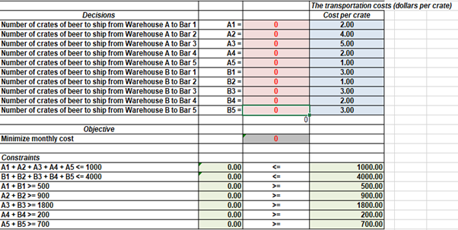

Each decision variable’s value is initialized to zero. The table renders the transportation cost per crate corresponding to each decision variable (A1, A2, A3, A4, B1, B2, B3, and B4). The transportation cost from Warehouse A to Bar 3 is the highest ($5) as compared to other rates which range from $1 to $4.

Initially, the objective function defined to minimize the monthly transportation cost is zero as well because of decision variable’s value initialised to zero. Similarly, the 7 constraints specified are formulated in the table with different inequalities. First two constraints possess limit on maximum number of crates transported from warehouse to each bar whereas other 5 constraints possess limit on minimum requirement of crates in each bar.

After running the solver on above model, we get the following results:

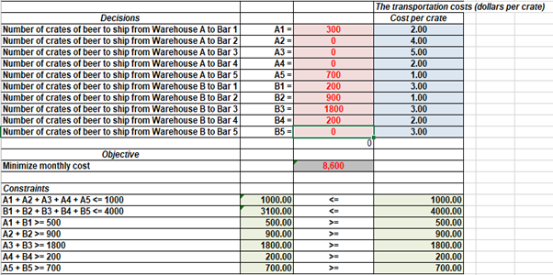

The total minimum monthly transportation cost with specified constraints is $8600. This is achieved by shipping 300 crates of beer and 700 crates of beer from Warehouse A to Bar 1 and Bar 5 respectively. Warehouse B ships crates of beer to all the bars except Bar 5. Warehouse B transports 200, 900, 1800 and 200 crates of beer to Bar 1, Bar 2, Bar 3 and Bar 4 respectively.

Warehouse A doesn’t ship anything to Bar 2, Bar 3 and Bar 4. This can be due to its comparatively higher transportation costs to these bars in contrast to Warehouse B. The solver utilized the Warehouse B due to its cheaper transportation cost to deliver the allowed capacity of these bars to achieve the minimal transportation cost. This can be boiled down to Warehouse B as well. There is a difference of $2 per crate in transportation cost from Warehouse A to Bar 5 as compared to Warehouse B, hence, Warehouse A is chosen to deliver the allowed capacity to Bar 5. On the similar lines, the transportation cost from Warehouse A to Bar 1 is $1 less than that of warehouse B. Therefore, 300 crates of beer is chosen to be delivered from Warehouse A to Bar 1 as compared to only 200 crates of beer from Warehouse B.

200 crates and 300 crates are delivered from Warehouse A and Warehouse B to Bar 1 respectively, summing to 500 crates of beer to Bar 1. Total 900 crates of beer are supplied to Bar 2 from Warehouse B only. Complete 1800 crates of beer are carried from Warehouse B to Bar 3 and there is none transported from Warehouse A. This scenario is same for Bar 4 wherein all the 200 crates of beer are taken off from Warehouse B only. Bar 5 is receiving supplies (700 crates of beer) from Warehouse A only.

All the constraints are binding constraints except the constraint 2 (number of crates of beer to be transported from Warehouse B to all the bars). There is a slack of (4000 - 3100) = 900 crates of beer in Warehouse B. This is in contrast to the Warehouse A, wherein Solver has utilized all the resources (1000 crates of beer) to achieve the optimal solution.

**One-way sensitivity analysis**

Applying one-way sensitive analysis for the RHS of the first, second and third constraints in the model , we investigate how the optimal (minimize) transportation cost varies, with changes in the capacity (the number of beer cases) in warehouse A and B and in the number of beer cases shipped to bar 1

Firstly, based on the result of the optimal solution, the first constraint that the brewery has 1000 cases at warehouse A is binding. Therefore, we would like to investigate the impact of changing the number of cases at warehouse A (cell D20) from 0 to 2000 units (with an increment of 100 units) on the minimum transportation cost and the number of cases delivered to each bar from warehouse A and B respectively. Using solver table for linear programming model, we get the one-way sensitive report as below:

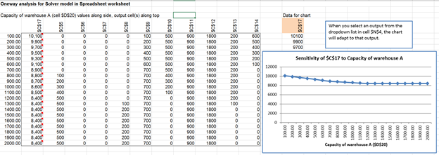

As is illustrated in the Figure above, for every 100 units increase in warehouse A’s capacity, the optimal (minimum) transportation cost decreases by $200 between 100 to 700 cases, by $100 from 800 to 1200 units and then stays the same at $8,400 between 1200 and 2000 cases. We can increase the capacity of warehouse A to 1200 unit to minimize the transportation cost.

The unit of cases shipped from warehouse B to bar 2(900) and bar 3(1800) is insensitive ( does not change) to the variation in the warehouse A’s capacity, whereas the unit of cases shipped from warehouse B to bar 1, 4 and 5 will experience a downward trend and the unit of cases shipped from warehouse A to bar 1, 4, and 5 will go up. The unit of cases shipped from warehouse A to bar 2 and 3 will be always 0 (does not depend on the warehouse A’s capacity).

Secondly, we examine the impact of changing the number of cases at warehouse B (cell D21) from 3000 to 6000 units (with an increment of 100 units) on the minimum transportation cost and the number of cases delivered to each bar from warehouse A and B respectively. Result is presented below:



The result of this analysis shows that the optimal (minimum) transportation cost( $8,600), the unit of cases shipped from warehouse A to bar 1(300) and bar 5 ( 700), the unit of cases shipped from warehouse B to bar 1(200), bar 2(900), bar 3 ( 1800) and bar 4 ( 200) is insensitive ( does not change) to the variation of warehouse B’s capacity. The unit of cases shipped from warehouse A to bar 2,3,4 and from warehouse B to bar 5 will always be 0 (does not depend on warehouse’s B capacity). Regardless the capacity of warehouse B, the optimal minimum transportation cost will always be $8,600. Therefore, we can reduce the capacity of warehouse B to 3100 units in order to minimize the cost of transportation.

Thirdly, we examine the impact of changing the number of cases delivered to bar 1(cell D22) from 100 to 1000 units (with an increment of 50 units) on the minimum transportation cost and the number of cases delivered to each bar from warehouse A and B respectively. Result is presented below:

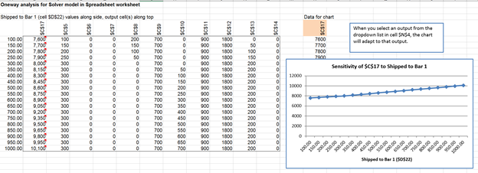

The result of this analysis shows that for every 50 units increase in cases delivered to bar 1, the optimal (minimum) transportation cost increases by $100 between 100 to 300 units, by $50 from 350 to 500 units and then by $1500 between 500 and 1000 units.

The unit of cases shipped from warehouse A to bar 5(700) and from warehouse B to bar 2(900) and bar 3 (1800) is insensitive ( does not change) to the variation in unit of cases delivered to bar 1, whereas the unit of cases shipped from warehouse A to bar 1 and from warehouse B to bar 1,4 will experience an upward trend and the unit of cases shipped from warehouse A to bar 4 will go down. The unit of cases shipped from warehouse A to bar 2 and 3 and from B to bar 5 will be always 0 (does not depend on the warehouse A’s capacity).

**Two-way sensitivity analysis**

Applying two-way sensitive analysis for the RHS of the 4th and 5th constraints in the model, we investigate how the optimal (minimize) transportation cost varies, when we vary both parameters: the number of beer cases shipped to bar 2 from 100 to 1900 and bar 3 between 1000 and 2800 units. Here below is the result:

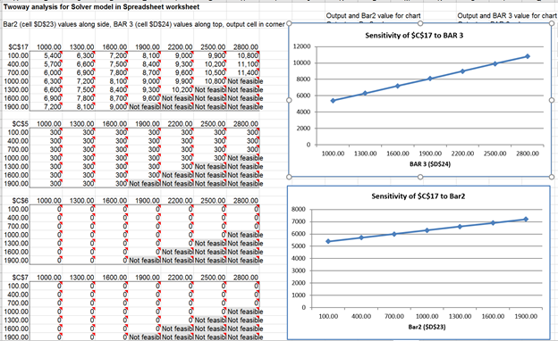

In general, if we vary both parameters mentioned above, the total optimal transportation cost will be increased (sensitive) to the variation of unit of cases shipped to bar 2 and 3. There will be no feasible solution if we vary the unit of cases shipped to bar 2 and bar 3 to above 1900, etc…

The unit of cases shipped to bar 1 stays at 300 ( insensitive) when we vary both parameters. There will be no feasible solution if we vary the unit of cases shipped to bar 2 and bar 3 to above 1900, etc…

The unit of cases shipped to bar 2 and 3 will be always 0 ( does not change) when we vary both parameters. There will be no feasible solution if we vary the unit of cases shipped to bar 2 and bar 3 to above 1900, etc…

**Conclusion**

In the project, our team was able to obtain the optimal solution for Buffalo Bill’s Brewery using Microsoft Excel and Solver add-in that will keep the transportation cost to the minimum. We were able to find out the exact numbers of crates to be shipped from Warehouse A and B to Bar 1 to 5.

Our optimization model shows that, based on the inputs provided, the company will ship from Warehouse A the whole 1000 crates in inventory and 3100 crates from Warehouse B to the bars. Warehouse A will mainly distribute to bar 1 and 5 while Warehouse B will distribute to most of the bars except bar 5. This will meet the minimum requirements for all 5 bars to avoid lost sales and will use up 4100 crates from both storage locations, leaving 900 crates in Warehouse B. This means the next time the bars make an order, the company only have to stock up the remaining number of crates that needs to be fulfilled.

In addition to the optimization model, we also performed one-way and two-way analyses for the company to understand how the optimal solution varies as the different parameters change, such as the capacity of Warehouse A and the number of crates from Bar 1. We concluded that the capacity is not sensitive to the shipping cost but the number of crates ordered from Bar 1 is.

An advantage of this model is that it is very flexible and easy to modify. It will be helpful when the company acquires more clients and needs to distribute to more bars or buy a new warehouse in the future. Using this model, they can add in new constraints and inputs so that new optimal solution can be calculated, telling them exactly which warehouse should supply to which bar and how many. Therefore, even when the company grow, making these decisions will not be more challenging.